# SUPPLEMENTARY FIGURES (18)

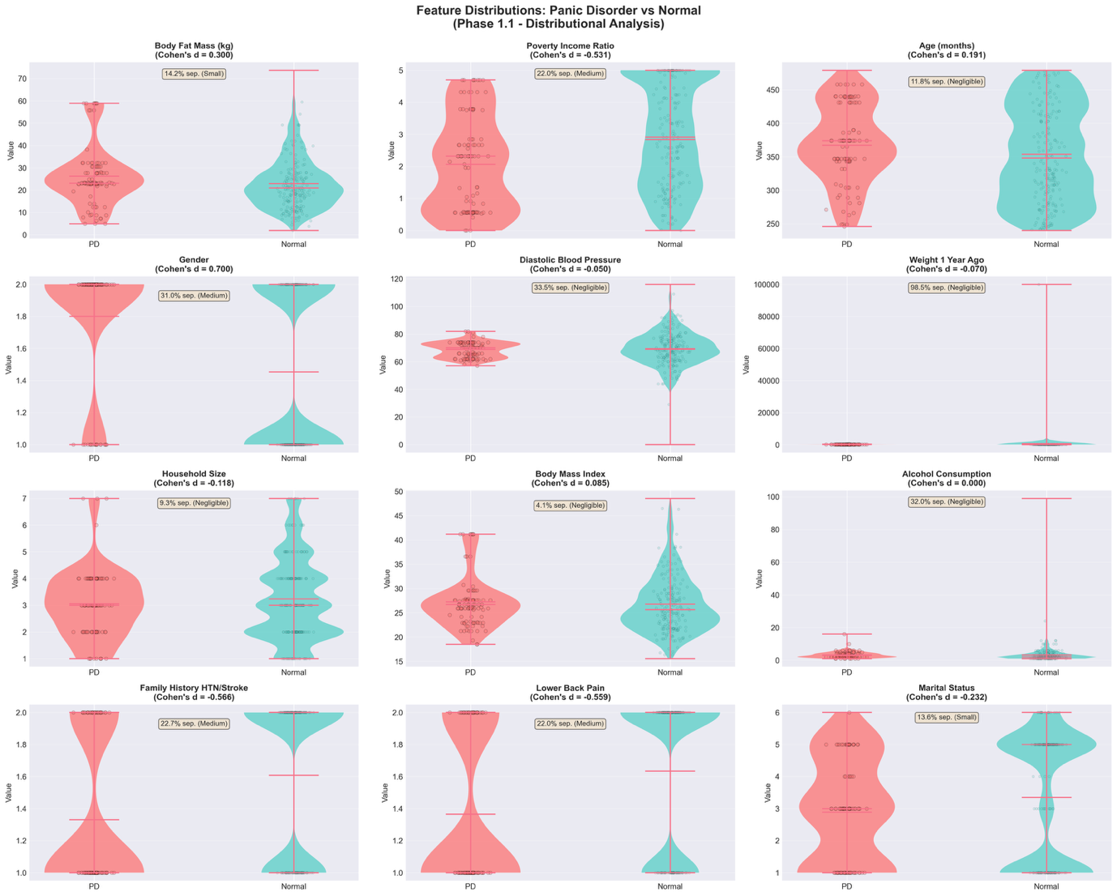

**Supplementary Figure S1.** Individual Feature Distributions Across Groups. Violin plots of all 11 features stratified by PD status (PD n=115 red, Normal n=3,029 teal). Gender shows largest difference (d=0.700), followed by family history, pain, poverty. Physiological features show substantial overlap. Validates Table 2: individual features show modest-to-weak discrimination.

**Source:** phase1_distributions/Figure1_violin_plots_all_features.png

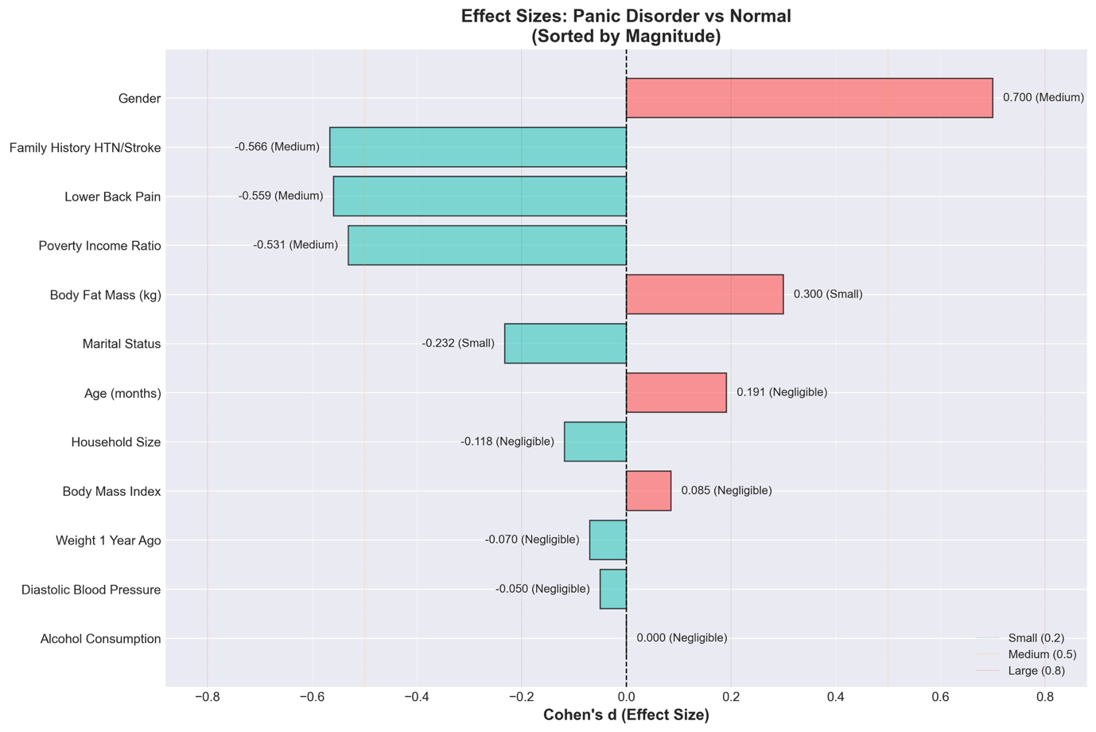

**Supplementary Figure S2.** Feature Effect Sizes Ranked

Horizontal bar chart of Cohen's d effect sizes, ordered by magnitude. Gender highest (d=0.700), five features show negligible effects (|d|<0.2). Mean absolute effect: 0.284 (small). Color-coded by domain. NO feature achieves strong discrimination (d>0.8).

**Source:** phase1_distributions/Figure2_effect_sizes_ranked.png

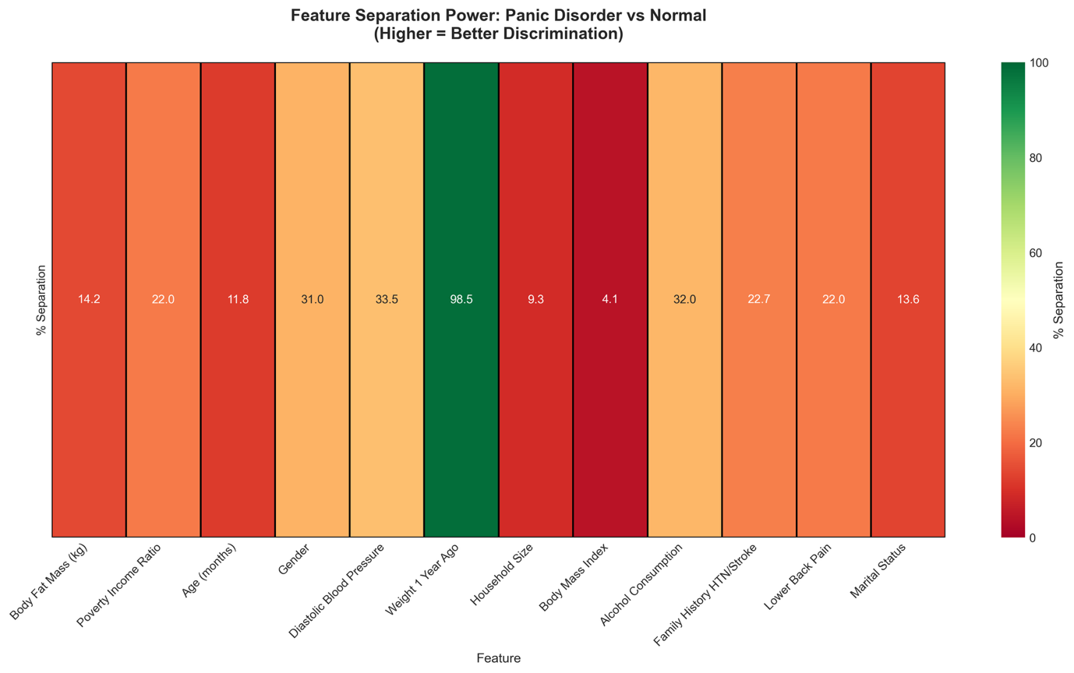

**Supplementary Figure S3.** Feature Separation Heatmap

Heatmap of percentage separation (non-overlapping area) for each feature. Gender shows maximum 31.0% separation. Most features show <20%. Mean separation: 19.4%. NO single feature achieves >32% separation.

**Source:** phase1_distributions/Figure3_separation_heatmap.png

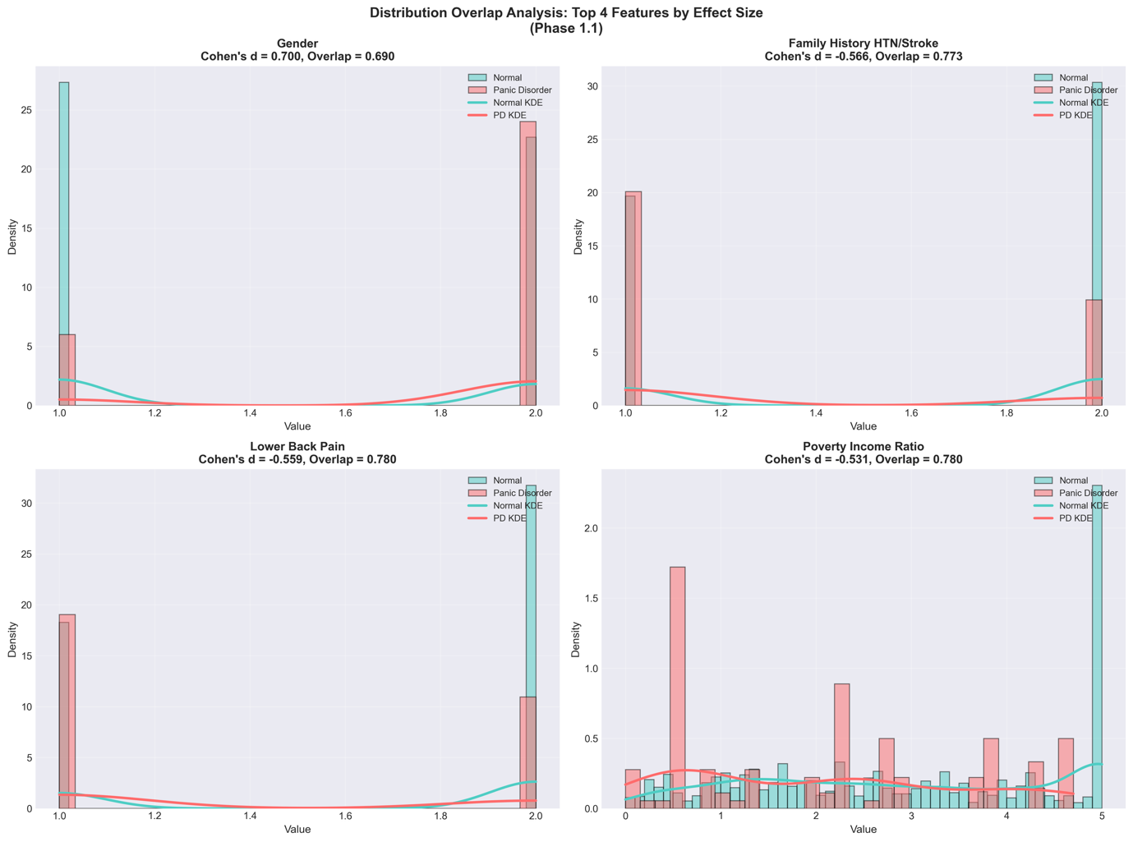

**Supplementary Figure S4.** Distribution Overlaps for Top Four Features

Overlapping histograms for gender, family history, pain, poverty. Despite being 'top discriminators,' substantial overlap visible (70-80%). Gender shows clearest separation but still ~31% overlap.

**Source:** phase1_distributions/Figure4_distribution_overlaps_top4.png

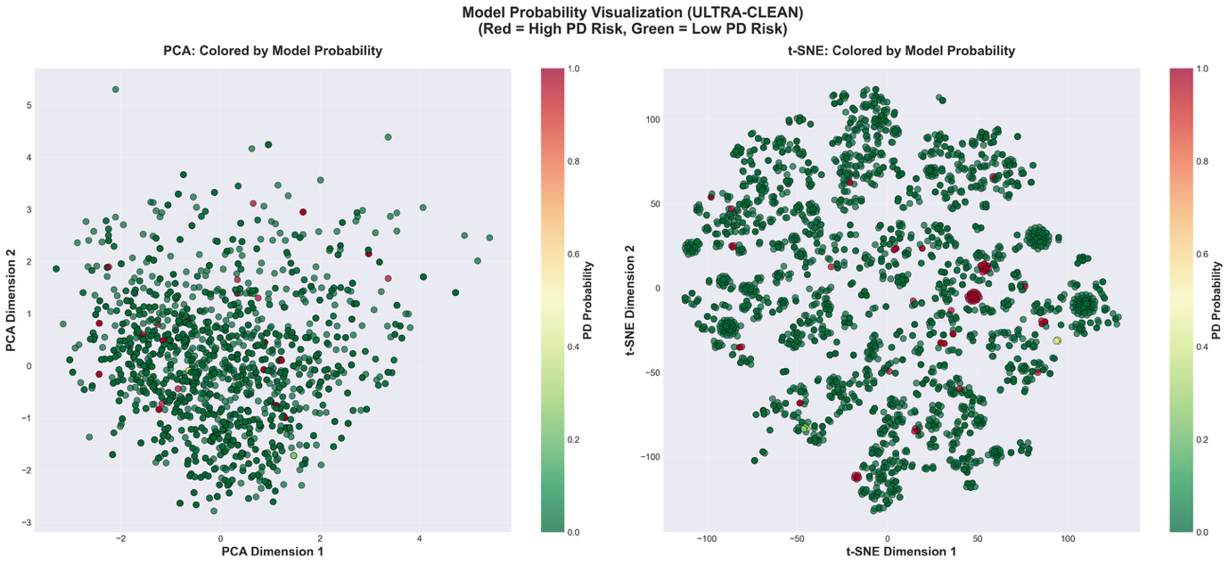

**Supplementary Figure S5.** UMAP Colored by Model Predicted Probability

UMAP with gradient coloring by predicted PD probability (blue=0% to red=100%). Color gradient reveals underlying structure not visible in 2D projection. Most PD cases in red regions, normals in blue.

**Source:** phase1_2_visualization_ULTRA_CLEAN/Figure2_probability_colored_ULTRA_CLEAN.png

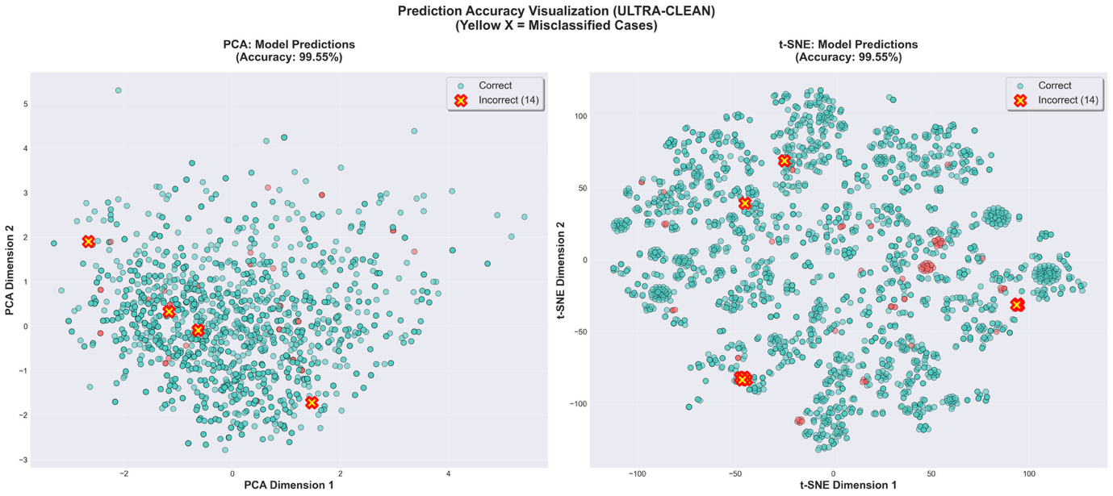

**Supplementary Figure S6.** UMAP Showing Correct vs Incorrect Predictions

UMAP with incorrect predictions marked with yellow 'X' (n=3 total: 1 FP, 2 FN). Errors do NOT cluster, suggesting complex multidimensional patterns rather than systematic 2D boundary issues.

**Source:** phase1_2_visualization_ULTRA_CLEAN/Figure3_prediction_accuracy_ULTRA_CLEAN.png

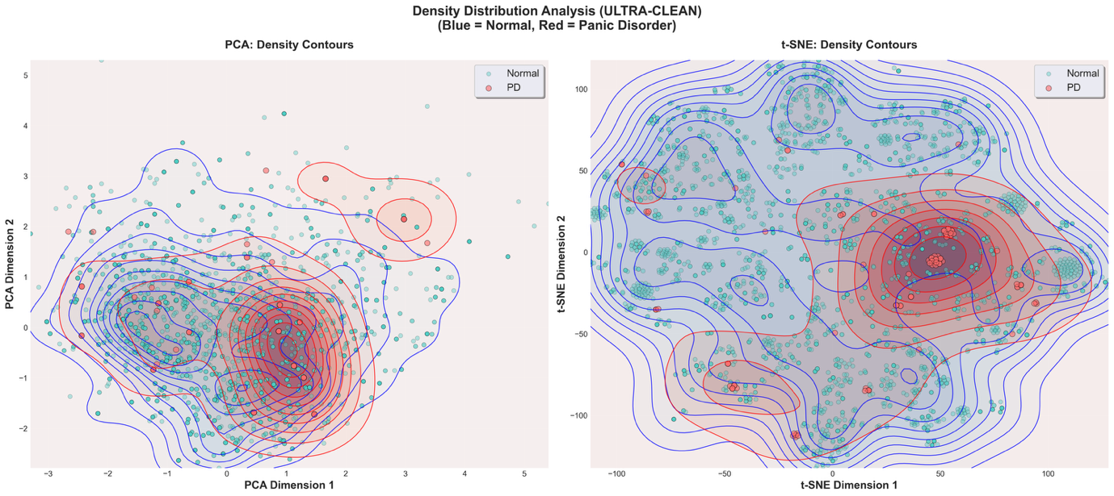

**Supplementary Figure S7.** Density Contours in UMAP Space

UMAP with kernel density contours for PD (red) and Normal (blue). Contours partially overlap: ~40% of 2D space contains both groups. Consistent with moderate Silhouette scores.

**Source:** phase1_2_visualization_ULTRA_CLEAN/Figure4_density_contours_ULTRA_CLEAN.png

**Supplementary Figure S8.** Complete Interpretable Decision Tree Structure

Full decision tree (max_depth=5, 6 leaves) with branching structure. Root splits on PIR ≤ 4.71. Tree's primary failure visible: most participants classified as PD, creating 464 false positives. Uses only 4 of 11 features.

**Source:** phase2_1_decision_tree_ULTRA_CLEAN/Figure1_decision_tree_full.png

**Supplementary Figure S9.** Decision Tree Feature Importance Comparison

Bar chart comparing decision tree vs gradient boosting importance. Tree uses only 4 features with extreme concentration (PIR 88.2%), ignoring 7 features (0%). Gradient boosting distributes across all 11 (max 16.1%).

**Source:** phase2_1_decision_tree_ULTRA_CLEAN/Figure2_feature_importance_tree.png

**Supplementary Figure S10.** SHAP Feature Importance Bar Chart

Horizontal bar chart of mean absolute SHAP values. Alternative to beeswarm (Figure 2). Body fat and poverty tied at 16.1%. No dominant feature (max<17%), balanced distribution. Color-coded by domain.

**Source:** phase2_2_SHAP_ULTRA_CLEAN/Figure2_SHAP_importance_bar.png

**Supplementary Figure S11.** SHAP Dependence Plots for Top Four Features

Four-panel scatter plots: SHAP value vs feature value for body fat, poverty, age, BMI. Non-linear patterns visible. Vertical spread quantifies interaction effects—same value produces different SHAP depending on other features.

**Source:** phase2_2_SHAP_ULTRA_CLEAN/Figure3_SHAP_dependence_top4.png

**Supplementary Figure S12.** Detailed Visualization of Top Three Interactions

Three scatter plots for top 3 interactions: Body fat × Age (1.047), PIR × BMI (1.016), Age × BP (0.807). Visual demonstration of synergy: effects AMPLIFY in combination, not additive.

**Source:** phase2_2_SHAP_ULTRA_CLEAN/Figure5_SHAP_top3_interactions.png

**Supplementary Figure S13.** SHAP Waterfall Examples for Individual Predictions

Waterfall plots for three cases: True Positive PD, True Negative Normal, False Negative. Shows feature-by-feature contributions starting from base value. Provides individual-level interpretability.

**Source:** phase2_2_SHAP_ULTRA_CLEAN/Figure6_SHAP_waterfall_examples.png

**Supplementary Figure S14.** SHAP Value Distributions: PD vs Normal Comparison

Side-by-side violin plots comparing SHAP distributions between PD (red) and Normal (teal). Body fat shows largest difference: PD +1.915, Normal -3.019. Visual representation of Table 4 class-stratified analysis.

**Source:** phase2_2_SHAP_ULTRA_CLEAN/Figure7_SHAP_PD_vs_Normal_comparison.png

**Supplementary Figure S15.** Poverty-Income Ratio Distributions by Group

Overlapping histograms of PIR for PD (mean 2.06±1.47) vs Normal (2.91±1.61). PD shifted leftward with 25.8% in extreme poverty vs 6.5% Normal. Despite shift, substantial overlap (>75%).

**Source:** poverty_paradox_investigation/Figure1_poverty_distributions.png

**Supplementary Figure S16.** PD Prevalence Across Poverty Quartiles

Bar chart of prevalence by quartile: Q1 6.42%, Q2 4.08%, Q3 2.92%, Q4 1.16%. Monotonic decrease, 5.5-fold difference. Error bars show 95% CI. Chi-square trend significant (p<0.001).

**Source:** poverty_paradox_investigation/Figure2_quartile_analysis.png

**Supplementary Figure S17.** Feature Correlations with Poverty-Income Ratio

Horizontal bar chart of Pearson correlations between PIR and all features. Age strongest positive (+0.20), explaining Simpson's Paradox. Household size, marital status, alcohol negative. Body composition negative (BMI -0.14, fat -0.08).

**Source:** poverty_paradox_investigation/Figure3_poverty_correlations.png

**Supplementary Figure S18.** Phenotypic Differences Among PD Cases by SES

Grouped bars comparing low-PIR vs high-PIR PD subgroups. Wealthier PD: older (+31.5 months, p=0.009), more body fat (+7.1 kg, p=0.012), more pain (+31.6%, p=0.001). Suggests PD heterogeneity by SES.

**Source:** poverty_paradox_investigation/Figure4_pd_subgroup_differences.png